# Kathmandu University

**Department of Computer Science and Engineering**

## Dhulikhel, Kavre



**A Project Report on**

**“ Namobudhha File System ”**

**[Code No: COMP 206]**

**(For partial fulfillment of 2nd Year/ 2nd Semester in Computer Science/Engineering)**

**Submitted by Sanjiv Gautam(17) Bigyan Ghimire (18)**

**BhanuBhakta Joshi(22) Pritam Shrestha(52)**

**Submitted to**

**Mr. Dhiraj Shrestha Lecturer**

**Department of Computer Science and Engineering**

**Submission Date: 2018/02/15**

**Bonafide Certificate**

This project work on

**“Namobuddha File System” is the bonafide work of**

**“ Sanjiv Gautam ” " Bigyan Ghimire "**

* **BhanuBhakta Joshi "**
* **Pritam Suwal Shrestha "**

**who carried out the project work under my supervision.**

**Project Supervisor**



**Name: Dhiraj Shrestha**

**Lecturer**

**DoCSE**

**Abstract**

Namobuddha file system is the file system developed to manage files, search them. This filesystem was developed so as to make it easier for Namobuddha Municipality employees to search files had it been saved using our FileSystem.

We have used Python Django Framework as the principle programming language that does all the back end and HTML, CSS and JavaScript (jQuery) for front end support. The front end was made easier with use of Twitter Bootstrap.

**Keywords:** *Django, jQuery, HTML, CSS, Bootstrap*

i

# TABLE OF CONTENTS

**TITLE PAGE NO.**

**Abstract** i

**List of figures** ii

**Abbreviation** iii

**Chapter 1: Introduction** 1

* 1. Background

1

* 1. Objective
  2. Motivation and Significance 1

**Chapter 2: Related Works** 2

**Chapter 3: Design and Implementation** 3

* 1. Design Process 3
     1. Research and Study 3
     2. Graphic Designing 3
     3. Core Programming 3
     4. Program Testing 3
  2. System Requirement Specifications 4
     1. Software Specifications 4
        1. Front End Tools 4
        2. Back End Tools 4
     2. Hardware Specifications 4

**Chapter 4 : Discussions on the Achievements** 5

4.1 Features 5

**Chapter 5: Conclusion and Recommendations** 6

* 1. **Limitations** 6
  2. **Future Enhancement** 6

**Reference Appendices**

## List of Figures

|  |  |  |
| --- | --- | --- |
| **Figure** | **Page no.** | . |
| **3.1 System Diagram of our model app** | **4** |  |
| **Gnatt Chart** | **8** |  |
| **Screenshots** | **8** |  |

**Acronyms/Abbreviations (if any)**

**HTML Hyper Text Markup Language**

**CSS Cascading StyleSheet**

**JS JavaScript**

**DOM Data Object Model**

# Chapter 1: Introduction

## Background

Searching is one of the core part of the any software built. From Ms-Word to different websites, softwares we have searching. So, it can be counted as fundamental part of any program. From Facebook Messages, to twitter tweets we can search them.

File searching is one of the subset of searching which comes handy to needy users. There have been many softwares that searches your files, categorizing from type, names. The best example is searching of files in windows provided for us by Microsoft Windows.

## Objectives

The major objectives of this project are:

* To develop a file system which can search the file in robust manner.
* To be able to add files and search them according to different categories
* To be able to add reminder for different files which may need attention in short duration time.
* To categorize files on the basis of task completed, pending or undefined.
* To get acknowledge with Python Framework like Django and Flask and JavaScript, Bootstrap which helps to develop Web Development habit.

## Motivation and Significance

Our Project was a request from a client from Namobuddha. So, our motivation was the fact that we were the chosen one out of sixties from our class. Also, we have a chance to visit Namobuddha Municipality and to be able to build a software for a municipality is something to be proud of.

# Chapter 2: Related Works

File Searching in Explorer in Windows, Linux is the best example we can see in File Searching. Besides, websites like Google Docs, Google Drive also has file searching algorithm which searches for files saved when we work on them. To search the file, we just type the filename in search field and it will display the files, with the names that begins with the name we have typed in. The similar algorithm follows in our work.

Namobuddha File System provides the similar facility to users. However, in addition to those facility in file searching system, we have much more flexibility than existing system. We can even add comments/ message which is fruitful if we have to see the info about the file without opening them. As the users are from Nepal, we can even add Nepali date to set the reminder in task in Nepali date. We can search the work with different categories, the task remaining days e.t.c.

## Chapter 3: Design and Implementation

## Design Process

### Research and study

First thing of the Project was that it was based on need of Software in the office. So, we paid the visit to Namobuddha Municipality and enquired them about their need and our software was based on their demand.

### Graphics Designing/ Front End Designing

The last thing a client want is the poor design of the software or app they are using. So we focused on making the software look good at the first place before we dived into the backend. As our software is browser based, we went for HTML and CSS. The best part of HTML and CSS is that they are easy and their frameworks like Bootstrap, Foundation are premade and very easy to use.

So, we went for Bootstrap. Bootstrap provides easy integration of HTML and CSS. Basic Knowledge of HTML and CSS and Bootstrap is easy thing to do. The only thing that was difficult was positioning elements in different parts of windows, which we achieve after proper implementation of CSS.

In addition to this, JavaScript was used to do some task that was difficult to integrate using Python and CSS alone. We used jQuery framework from Javascript because it allows DOM manipulation easily.

### Core Programming

It is the foundation of the application. It includes the basic knowledge of the application which includes the source code of the application. The major part of our software lies here.

**Django Framework:** Django is the framework that allows to make browser based software, websites. It has gained its popularity thanks to its updates, easy to integrate and very easy data manipulation.

Here are major part of our programming:

1. **File Addition** :

First, the file has to be selected by browsing it from the dialog and have to be added. This part is controlled by front end for GUI. Then, file is added to database with the name of the file. Here, we can add message, category to search files, task state. These attributes are saved in our database for which we have used MySQL.

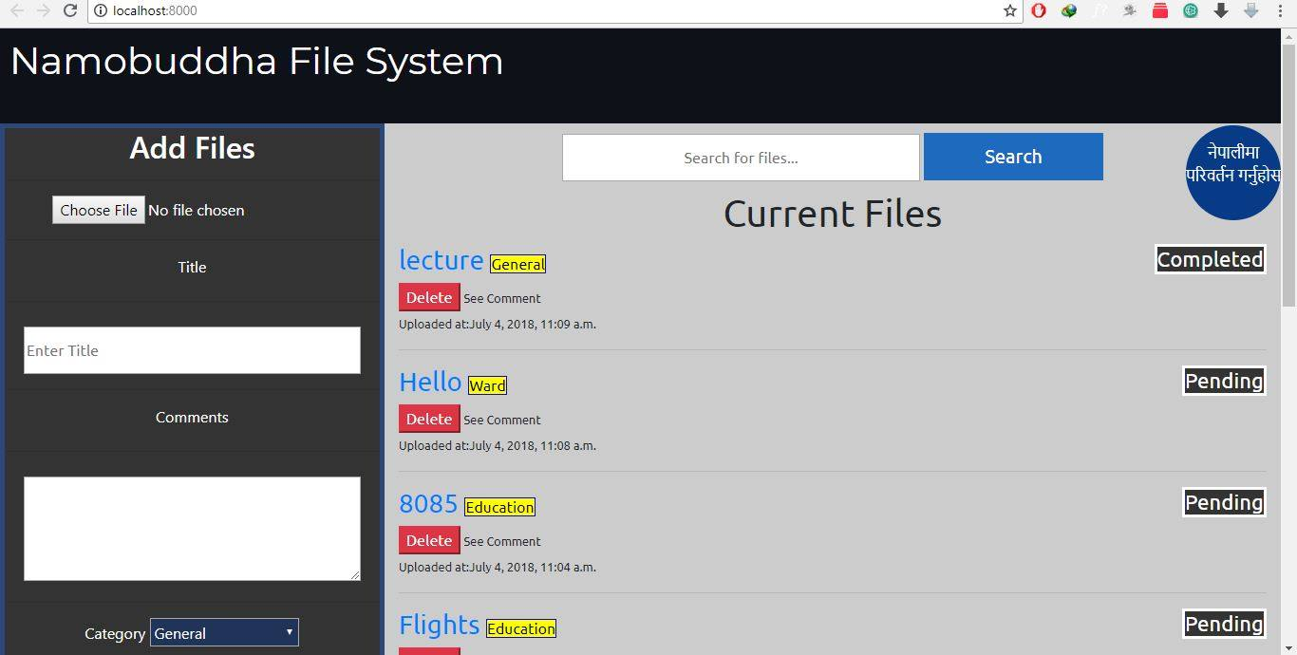

**B. File Searching**

Another part and most pivotal one is our File Searching, we can search the file based on different categories, as well as file name. We can see what are the comments we have added in the file which gives us the idea about the file. The task state of ‘Pending, Completed’ is shown as well .

ADDITION LEFT HERE… BIGYANE LE REPLY GARENA…

### Program Testing

Every Program needs to be tested. So, as a programmer, it is their job to mitigate the bugs and errors encountered in the program. So, we tested the program in our localhost, and as far as we can be sure , the program runs just fine and a computer literate person with a bit of instruction can handle our software easily because it is very simple design and easy to handle .

Bugs were encountered during file addition, especially with the file format type, but they were managed. So, the program runs fine.

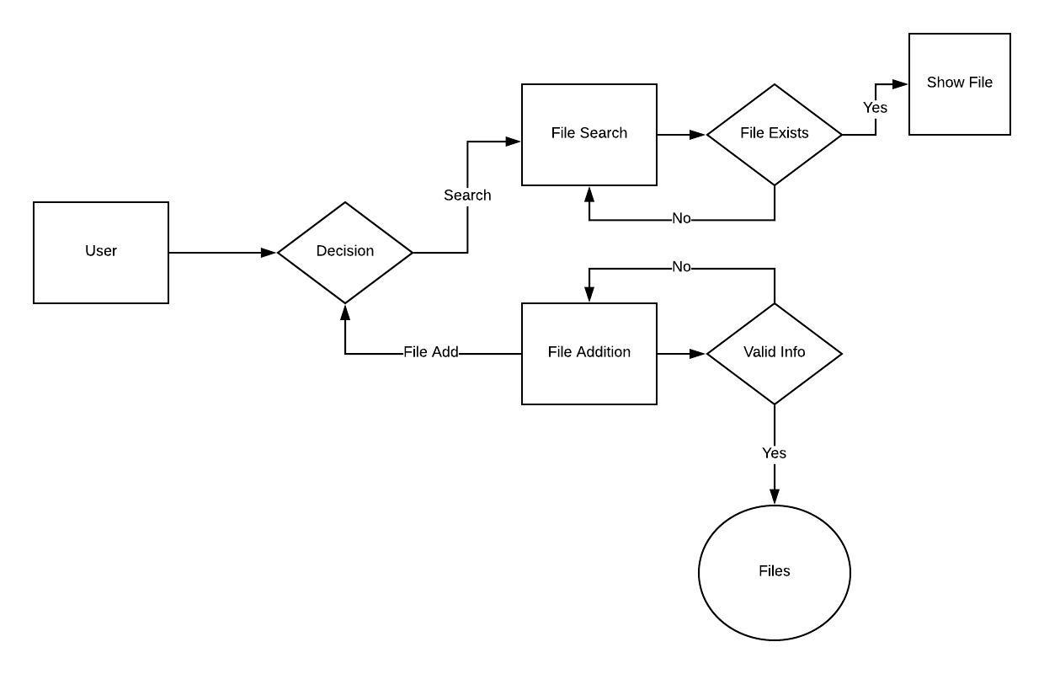

***Fig3.1.1:System Diagram of the Application***

## System Requirement Specification

### Software Specification

* + - 1. **Front End Tools:** HTML, CSS, JS
      2. **Back End Tools:** Python, MySQL
    1. **Hardware Specification**

Any computer that supports the Google Chrome and Django Specifications are compatible.

# Chapter 4: Discussion on the Achievements

Our primary objective was to send files between PC to Android and vice versa. But later, it was changed to Android to Android because its usage was limited. It was less feasible for monetization and separated GUI and features had to be added for PC version which was very tedious.

The deviation to new objective was not easy either. Connecting two android devices was a headache. This bug made the app crash every time we try to send images between two devices. Multiple devices showed OutOfMemory Exception and app crashed eventually.

Our transfer speed is equivalent to that of Xender. The image is easily accessed from our app which is not provided by Xender. We have p2p connection like Xender, so our core functioning is similar.

## Features

* + - Our project is focused on image file transference only, though it supports file transfer as well.
    - Easy access to gallery to send files.
    - One can take pictures from our app which can later be accessed while sending.
    - Navigation to Wifi Settings in one click.
    - It shows the information of connected devices which other sharing apps doesn’t.
    - Our app enables users in countries with low internet penetration and poor internet architecture to transfer and share files without using the Internet, by creating a Wifi- Direct to which other devices can connect.
    - Simple GUI

# Chapter 5: Conclusion and Recommendation

Our app could easily share image files on a click. The file transfer speed is comparable to popular sharing apps like Xender and ShareIt. Connection between two devices show no bugs. However, connecting multiple devices show some errors after connection has been established.

We could not integrate function in PC initially because of limitation of socket programming that require WAN to function. As a result, we needed to change our objective to connecting android devices only, which was a major shortcoming.

## Limitation

* + - Only image files can be transferred.
    - Connecting multiple devices shows some errors in file transfer.
    - Changing host devices lead application to crash.
    - Authentication permission is not asked if connected devices are of different apk level.
    - The IP addresses shown in the device information can be misused.

## Future Enhancement

Our ShareBahadur 2.0 could include PC to android as well as android to android file sharing features. It could share music, videos, documents, APKs, etc with chatting feature as well with a more comprehensive GUI.

# Reference

Delessio,C. & Darcey,L. (2012). *Android Application Development in 24 Hours, Sams Teach Yourself (3rd Edition) (Sams Teach Yourself -- Hours)*

Sierra,K.(2011). *Head First Java(2nd Edition)*

Gargenta,M.(2015). *Learning Android*

*Android Fundamentals:*[*http://developer.android.com/guide/components/fundamentals.html*](http://developer.android.com/guide/components/fundamentals.html) *https://github.com/git/git-reference*

7

**APPENDICES**

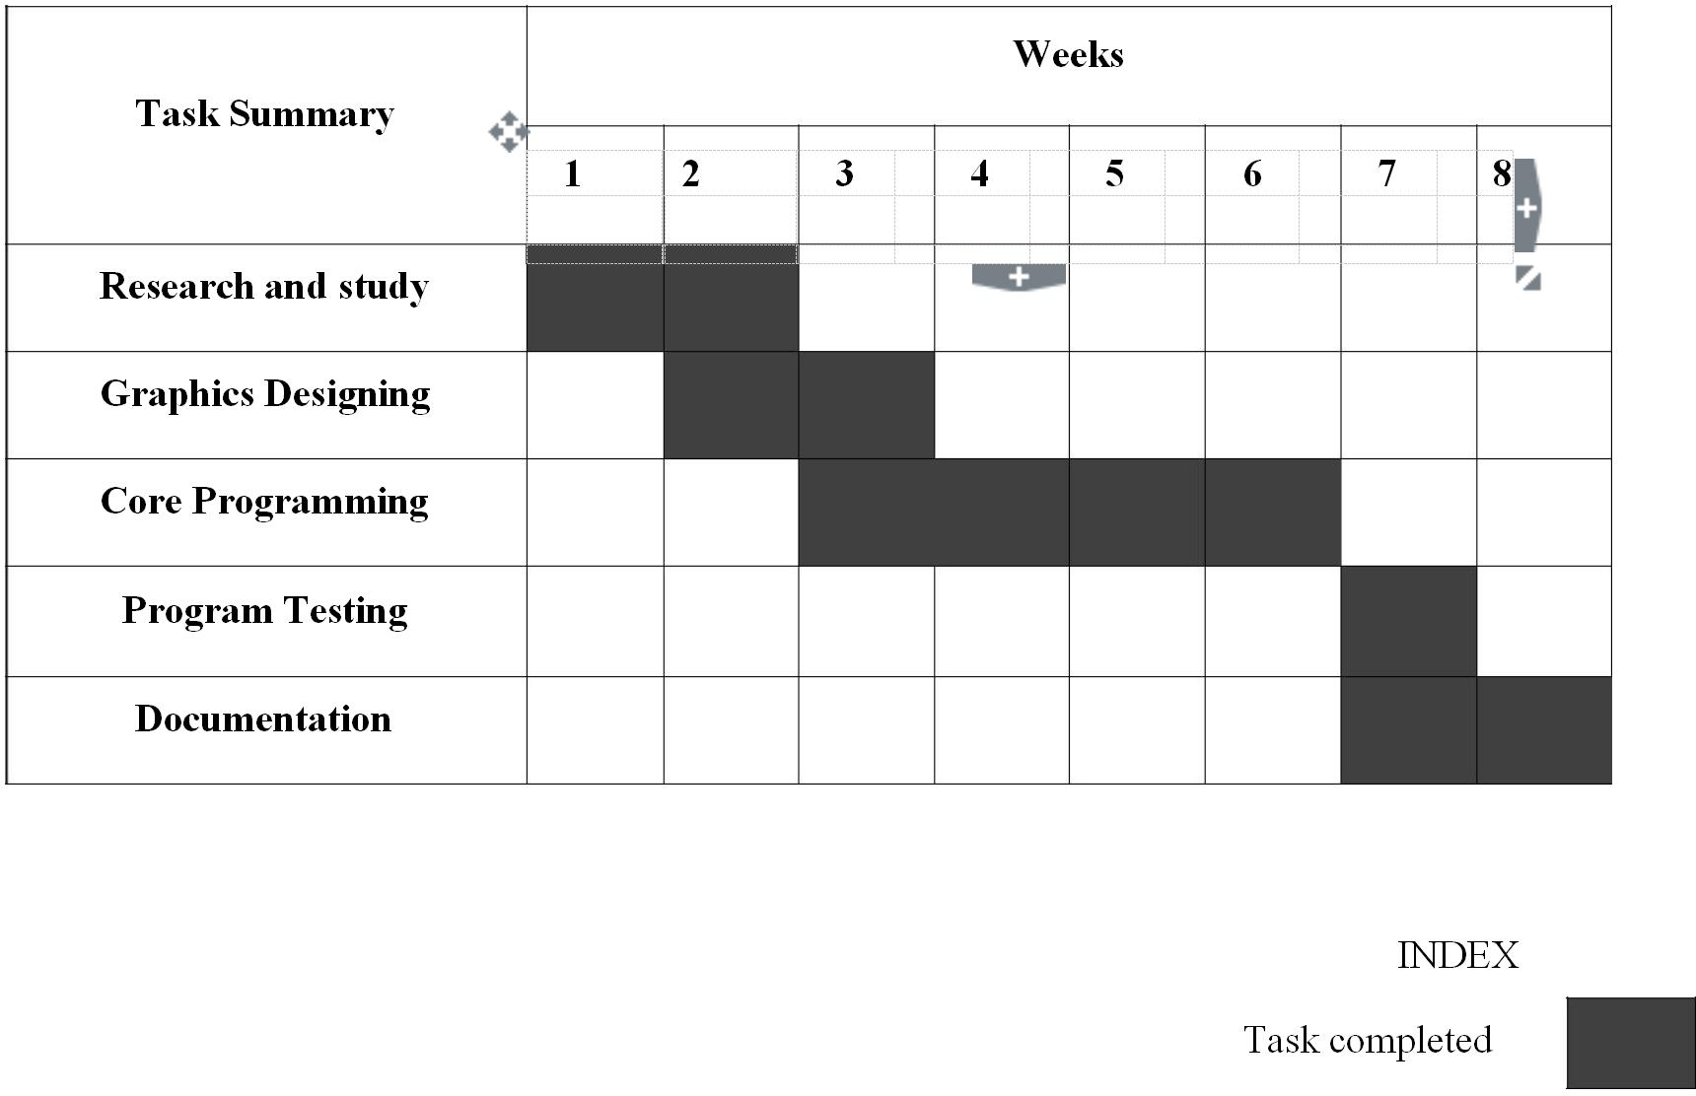

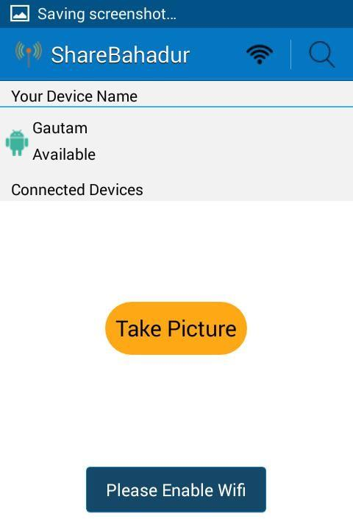

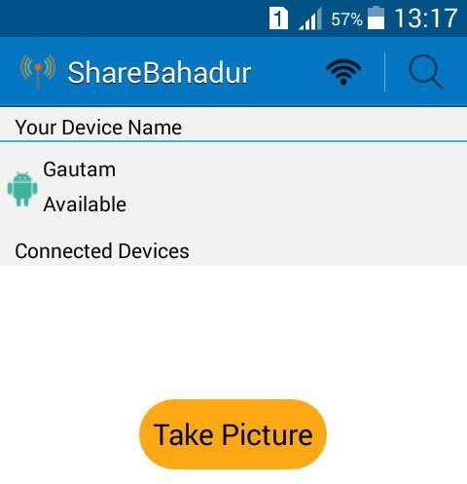

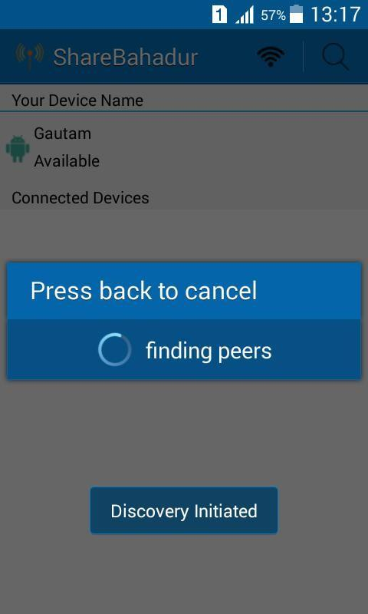

10